# Premature Optimization – Deliverable 2

## Erik Wright (ecwright)

## Julian Monticelli (JulianMonticelli)

## Brandon Hedges (brandonhedges82)

## Tegpartap Singh (teg-singh)

## Nathan Davidson (nathan-davidson)

## <https://github.com/JulianMonticelli/1530_Premature_Optimization>

## November 8 2017

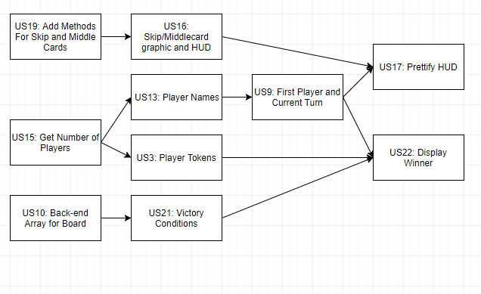

User Stories Completed:

Teg Singh: US15, US13, US9

Erik Wright: US21, US22

Nate Davidson: US19

Julian Monticelli: US16, US17

Brandon Hedges: US10, US3